
Certificate of Award
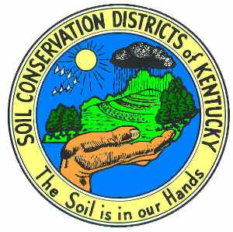

Presented to

In recognition of outstanding effort in promotion of and participation in the
Jim Claypool Art and Conservation Writing Contests

For the year

Given by the County Conservation District on , 20

_____________________________________
Chairman

